Elephant Hill – Douglas-fir Beetle Subgroup
Preamble
Douglas-fir beetle (DFB) management is a multi-year endeavour and all treatments must be monitored and assessed for efficacy. The tools described in this document will enable more targeted and efficient management of DFB within and adjacent to the Elephant Hill Fire. Three tools used in conjunction with sanitation harvest include, but are not limited to:
- Lindgren funnel traps
- Trap trees
- MCH
The first step in addressing DFB is locating active populations by aerial mapping and ground surveys. Aerial mapping is conducted the year following attack from June through July when the foliage of attacked trees turns bright red. These are the trees from which new broods of DFB emerge and attack new, green host trees. Within the fire perimeter it is often hard to distinguish between additional post-fire mortality and mortality caused by DFB attack. Therefore, follow-up ground surveys are necessary to identify the causal agent.
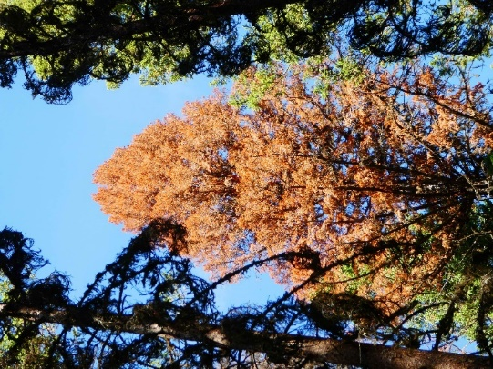 | 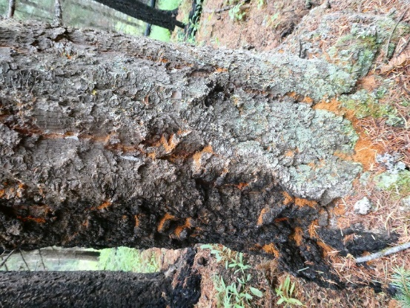
Left: Red foliage of DFB attacked Douglas-fir; and Right: DFB attack on green Douglas-fir with partially scorched bole.
When new DFB attack is located, determine the values at risk, likelihood of spread (hazard rating) and constraints. Examples of where DFB management may be implemented within and adjacent to the Elephant Hill Fire are:
- islands of green tree reserves are at risk
- DFB attack is adjacent to, or within green tree reserves on perimeter of fire
- DFB attack is threatening, or moving outside of, the fire perimeter into susceptible Fd types
The tools described in this document are intended to:
- contain and concentrate DFB in pre-determined areas designated for sanitation harvest
- protect green reserves and other small patches of high priority Douglas-fir from attack by DFB
Tools to contain and concentrate DFB or protect green trees for DFB attack must be in-place prior to flight (April or May dependent upon season weather). Typically, DFB flies in late May-June. Sanitation harvest and removal of all attacked trees and trap trees must be completed prior to the next flight the following spring.

Forest Retention Guidance
The following overriding guidance is found in: Nicholls, D. and Ethier, T. 2018. Post-Natural Disaster Forest Retention Guidance: 2017 Wildfires. FLNRORD, Resource Stewardship Division.

A Douglas-fir Beetle Management Unit (DFBMU) may be delineated in the context of a landscape-level assessment of DFB hazard in and surrounding the Elephant Hill Fire.
DFBMU’s require:
- a clear statement of the rationale and objectives,
- an evaluation of risk if DFB treatments are not undertaken,
- a statement of the expected outcomes of treatments and
- treatment efficacy monitoring.
DFBMU planning should involve all relevant stakeholders and consider, among other factors:
- the landscape-level hazard and risk of DFB outbreak,
- the season of the fire,
- the severity of the fire,
- the size of the trees affected and
- whether special management areas (e.g., OGMA, UWR) or inoperable terrain are present.
At low levels of infestation, DFBMUs can be used to attempt to protect specific values at the stand level (e.g., OGMA), by reducing the local (surrounding) risk of DFB infestations.
DFB logging should not occur in OGMAs. Exceptions should be strictly limited to:
- areas where there are relevant, strategic management goals and objectives set for OGMAs prior to DFB infestation, or
- the (rare) occurrence of exceptional, extenuating circumstances.
Integrating DFB management with retention guidance provided may result in conflicting objectives, particularly where ‘aggressive intervention’ strategies for DFB management are used. To help reconcile conflicting objectives, practitioners should plan DFB management strategies while considering the role of retention in ecosystem resilience and recovery:
- focus DFB management in existing, developed areas to minimize new road construction;
- use partial cutting systems wherever possible and
- where clear cut silvicultural systems are used for DFB sanitation, design cut blocks to encompass areas where at least 70% of the timber volume has been killed by wildfire.

Key forest health objectives post-wildfire: Douglas-fir forests
- Minimize future tree mortality from Douglas-fir beetle (DFB) and secondary bark beetle attack.
- Maximize removal of DFB during the operational salvage of burned wood and attacked “green retention” trees.
- Apply the most current DFB mapping results, hazard rating and burn severity maps to prioritize stands at highest risk to DFB attack within and outside fire perimeter.
- Monitor bark beetle populations within the burn perimeter and within a critical distance (1-5 km) outside the burn perimeter.
- Monitor for DFB and secondary bark beetle attack in stands outside the burn perimeter – most critical 2nd to 3rd year post-fire.

Tool 1: Mass trapping Douglas-fir beetle using Lindgren funnel traps
Mass trapping employs clusters of Lundgren multiple funnel traps baited with lures containing Douglas-fir kairomone, frontalin, ethanol and seudenol to attract and capture large numbers of DFB. The objective of mass trapping is to absorb DFB adults emerging from nearby currently infested Douglas-fir and reduce attacks on adjacent susceptible trees. This tactic is meant to compliment other management strategies and tactics such trap trees or MCH in conjunction with sanitation and selective harvest. Mass trapping can be used as a “mop-up” tool after sanitation harvesting, or in conjunction with MCH repellent in a “push-pull” operation. A well-maintained funnel trap operation does not become “saturated” and can continue to capture beetles throughout the flight period.
Potential settings for mass trapping with funnel traps include:
- Within severely burnt timber with little or no susceptible host adjacent to traps. This will help deplete DFB population in area.
- Within severely burnt timber with adjacent susceptible green reserves at risk (or with known DFB attack) where sanitation harvest is planned. This will draw beetles out of adjacent green reserves and from burnt trees.
- Trap in large openings where there is minimal risk of overflow attack (adjacent timber not susceptible or severely burnt).
- Special circumstance - as an augmentation to trap tree/bait sanitation blocks where ±1 ha blocks are planned for sanitation harvest
Mass trapping requires that traps are “serviced” from set-up in April until takedown in late August-September. Traps require bi-weekly servicing depending on the number of beetles flying. Placement of traps is critical, and access must be considered when planning trap location. Traps are occasionally damaged by bears, cattle and weather; therefore, they must be checked regularly.
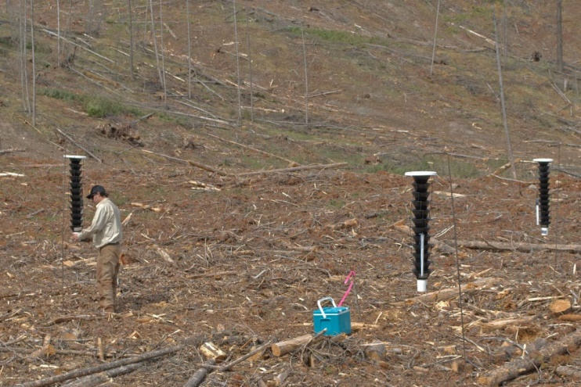
Photograph on left shows the 3-trap configuration of funnel traps and on right a diagram of funnel trap set-up.
Trap set-up: Use a 3-trap triangle of baited Lindgren funnel traps, with inter-trap spacing of 5 m to 10 m. Use multiple-funnel traps (4 to >12-funnel traps can be used, dependent upon supplier model) with a dry-cup, which will allow liquid to drain. Traps should be hung from aluminum (½ inch conduit) poles bent at the top. Short lengths of rebar are hammered into the soil and aluminum poles are placed over rebar. Hang trap lures according to supplier instructions with a piece of Vapona™ placed in the dry-cup. Vapona™ (Dichlorvos, domestic formulation) is usually sold in a “rubber” bar 2 inches wide x 6 inches long x ⅜ inch thick, which can be cut into 10 pieces and then set with a thin wire to hang in the cups. Some vendors supply Vapo-strips that are pre-cut for use in traps. The Vapona™ should be replaced periodically over the trapping season. Pheromone lures should also be replaced in mid-June.
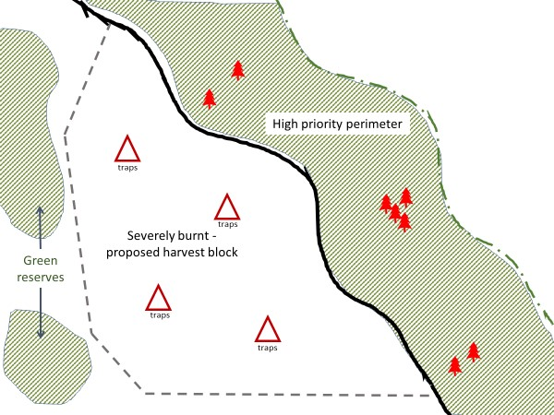
Diagram of trap layout in severely burnt area on fire perimeter. Green hatched area is outside fire perimeter.
Trap set-up protocol
- Trap sets in burnt settings must be at least 100 m from Douglas-fir trees in susceptible stand edges.
- Traps set within cutblocks must be at least 200 m from standing, live residual trees (or green reserves), and the standing trees should be protected with MCH or attacked trees within green reserves harvested post-attack.
- Maintenance of traps weekly to every 2 weeks, depending on trap catch.
- Hang lures on the outside of traps, at about ⅓ or ½ the height (or according to supplier instructions).
- Lures must be replaced in the second week of June.
- A “dry-cup” set up is easier to maintain and environmentally more manageable than “wet-cups”. Use pieces of Vapona™ to kill beetles in cups.
- Place beetle collections into Ziploc™ bags (label with site and collection date). Freeze 24-48 hours to ensure all beetles are killed.
- Move trap sets that are not catching beetles to another site or to an established site that is catching many beetles.
- Keep traps reasonably proximal to established roads to facilitate trap establishment and servicing.

Suppliers of funnel traps, Douglas-fir beetle funnel trap lures, tree baits and MCH:

Synergy Semiochemicals Corporation
synergy@semiochemical.com

WestGreen Global Technologies
net2officebthomson@shaw.ca

Distributions Solida Inc. (supllier of Vapo Strips)
www.solida.ca

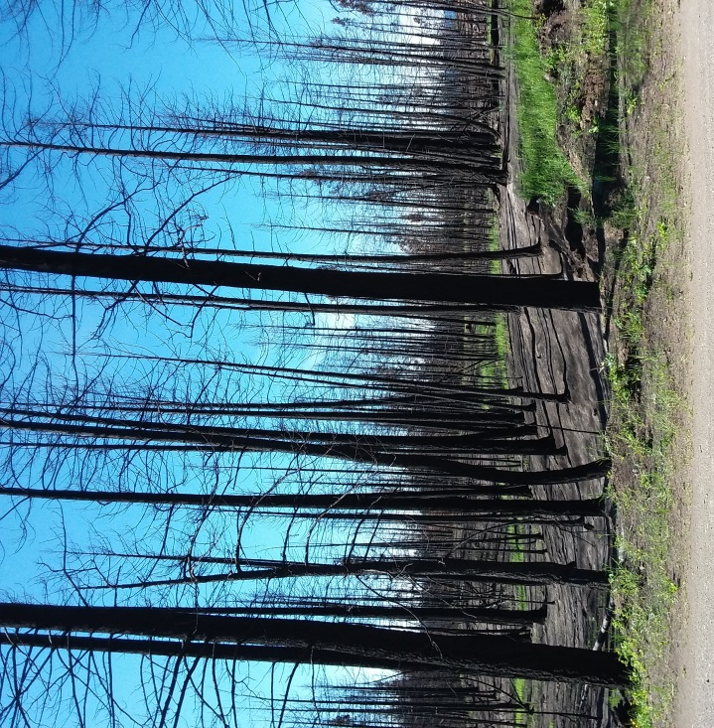 | 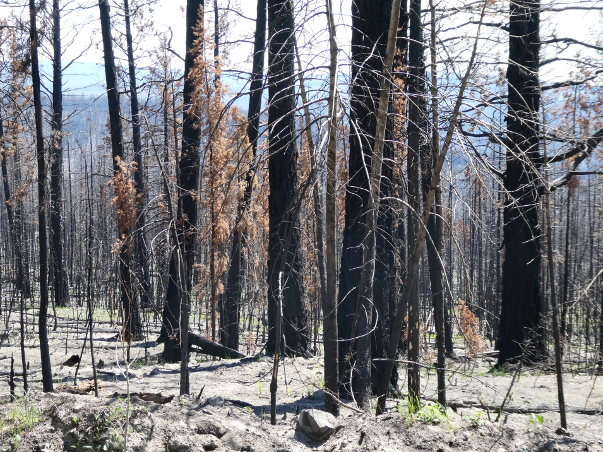
Highest susceptibility to DFB year following fire – blackened tree (no foliage, blackened bole; thick bark with acceptable phloem). DFB emerged from these settings in 2019 and attacked green trees with semi-scorched boles.

Tool 2: Trap trees in post-wildfire settings
Background: Trap trees are used to contain and concentrate DFB populations within defined areas (e.g. sanitation harvest blocks). Trap trees are used in conjunction with, and following, other treatments including mass trapping with funnels traps, MCH and sanitation harvesting. Trap trees are large, live Douglas-fir trees that are felled into the shade to attract DFB. Trap trees must be felled prior to DFB flight (early to mid April). Trap trees attract and absorb emerging DFB and must be removed after the end of beetle flight (August through March). Use one trap tree for every four standing current attack. Once trap trees have been removed from the site, DFB are killed during timber processing. Trap trees attract and contain beetles emerging from burnt trees, windthrow, stumps, and slash, thereby protecting adjacent healthy timber and green reserves. Trap trees may cause overflow attack on adjacent trees so plan for this in designing sanitation harvest block.
Guidelines for trap tree site location, tree selection and removal:
- select and place trap trees as close to a known infestation as possible;
- fall 1 trap tree for every 3-4 currently attacked trees. Green windthrown trees on-site may be used as trap trees, thereby reducing the number of trap trees required;
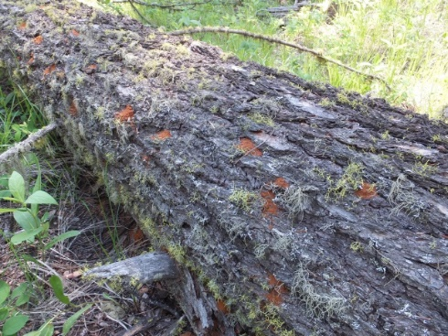
- trap tree diameters should be greater than or equal to 30 cm;
- trap trees should be cut prior to beetle flight in early spring (April 1);
- in chronic beetle areas, or stands with scattered beetle populations, grid with groups of trap trees at 400 m to 600 m intervals;
- trap trees should be cut in groups of 3-5 trees (or more);
- trap trees should be felled into the shade in such a way as to facilitate removal or subsequent treatment (trap trees left in direct sun do not attract beetles as well as those in a shaded environment);
- trap trees should be left unlimbed and unbucked;
- trap trees should be left on-site until August to attract DFB throughout their flight period;
- pre-felled rights-of-way, landings and skid trails can be used as trap trees to absorb DFB populations. Due to the large volume of timber felled during these operations, improper shading should not impede the effectiveness of control;
- large openings should not be created at trap tree sites;
- remove trap trees as early as possible after beetle flight. If infested logs are not removed prior to beetle emergence, tree mortality in the area will increase; and,
- survey/probe trap tree sites for spillover attack in adjacent standing trees before trap tree extraction and mark these attacked trees for removal. Trap trees should be removed as soon as practical following beetle flight but certainly before the next generation of beetles fly the following April.
Tool 3: MCH
Background: MCH (3-methylcyclohex-2-en-1-one) is an anti-aggregation pheromone used to disrupt or prevent beetle attacks. MCH can successfully repel DFB from vulnerable areas and can be used to help protect small, groups of high-value trees or stands. Through its application, DFB attacks have sometimes been reduced by over 90%. It is most effective when the number of infested or susceptible trees is low. MCH is applied prior to the annual beetle flight (typically in mid to late April).
In a stand that you are trying to protect, place MCH bubble caps on the north side of trees, as high as possible, at a 10m x 10m spacing. To protect individual trees, place two bubble caps on the tree (opposite sides).
Candidate areas to use MCH: MCH is not a stand-alone tool and must be used in conjunction with other strategies (sanitation harvest; trap trees; trapping). It can be used to protect small groups of trees or a small stand (e.g. part of an OGMA or green tree retention area). It can also be used in a push-pull scenario where you pull beetles into a planned sanitation block or into traps or trap trees and protect an adjacent area with MCH. It can also be used to prevent attack on small isolated patches of windthrow; large, susceptible trees (veterans; seed trees); and small islands of green trees inside the fire perimeter (which may or may not have sustained some bole scorching).
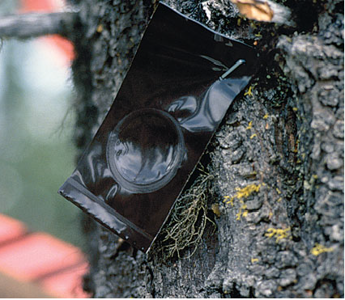
MCH bubble cap on Douglas-fir
Recommended supplier of Douglas-fir beetle funnel trap lures:
Synergy Semiochemicals Corporation
synergy@semiochemical.com
Phone 604-454-1122 or 604-568-8501
The recommended lure is Douglas-fir beetle high potency (“enhanced”).

The supplier for vapor tapes is:
WestGreen Global Technologies
net2officebthomson@shaw.ca
Phone (778) 298-8798

Suppliers for funnel traps and parts, and MCH :
Both Synergy and Westgreen* can supply funnel traps and MCH.
* Lindgren funnel traps from Westgreen are the original design.
The Thompson Okanagan Region, Forest Health Program has numerous Lindgren funnel traps available for use.

It is estimated that it takes about 1,700 beetles (1:1 ratio of females and males) to kill a tree. Therefore, if 100,000 DFB were trapped near susceptible trees, an infestation could be reduced by about 59 trees.

